The Crucial Questions You Must Ask when Planning a Funeral

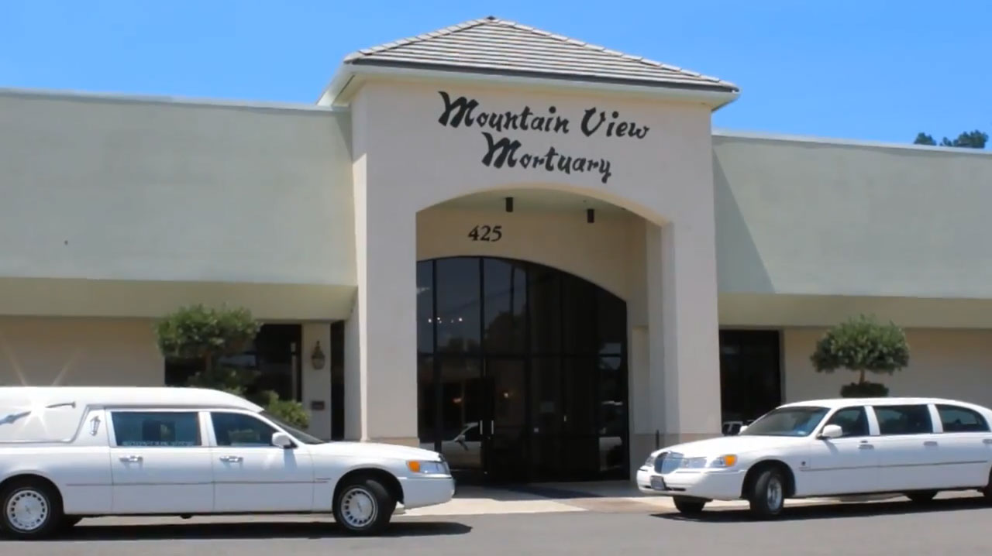

Mountain View Mortuary
425 Stoker Avenue
Reno, NV 89503
775-788-2199
Nevada Funeral Planning Guide

Preparing for a funeral, whether it is pre-planned or an immediate need, can be overwhelming. When selecting a funeral home, it is important to choose the one that is there to meet your individual needs. There are many options from basic cremation societies to full service funeral homes. Our hope is to give you information to help guide you through this sensitive situation.

Contents

Help with a Terminally Ill Person ………….………………………………….……….………..…….…. Page 3
First Steps: What Should You Do When a Loved One Passes? ................................. Page 4
Checklist for Meeting With a Funeral Home ……………………….….…..……………………….. Page 5
Cremation/Urns ….……………………………………………………………………..…….....……...……... Page 6
Full Burial/Caskets ……………………………………………………………………….…………..…..……… Page 8
Final Resting Place ……………………………………..…………………………………..………….…….…. Page 10
Donation of the Remains ……………………………………………………………………………………… Page 12
Having a Viewing or Funeral Service …………………………………………….…………..….…… Page 13
After the Funeral ……………………………………………………………………………………….….……… Page 15
Important Points to Consider ………………………………………………………………………….….… Page 16
Closing Remarks …………………………………………………………………………………………………... Page 17

Help with a Terminally Ill Person

Not all death is sudden and sometimes it can be more difficult knowing that a loved one is near death. However, helping a terminally ill person prepare for the end of their life can ease some of the burdens that accompany their illness. The most important thing to remember about a terminally ill person is that they are still alive and certain practices may help them cope with their impending end.
Creating a normalcy includes creating a sense of space, surround the person with objects that remind them of memorable times, religious affiliations or emotional ties. Aside from that, it is helpful to keep the rest of the area clean and clear of clutter. Keep in mind, your relationship with that person hasn’t changed. If you were always serious, they will expect the same. If you joked around, continue to provide a laugh or two. Remember, there is nothing you can do to change the situation or solve any problems, but you can be there to listen and visit.
As the illness progresses, a person who is facing a terminal illness may want to discuss the pre-planning of their funeral, they may not. Every family is unique and every situation is different. Some terminally ill people may feel a sense of comfort and control over their illness by knowing that they have decided their end, not the illness. This may be a good time to discuss the ceremony and the religious rites along with music and any readings. Remember, a terminally ill person needs you to just be there before, during and after.
Below is a list of local hospice providers who can also provide further assistance.

Circle of Life Hospice
1575 Delucchi Lane #214
Reno, NV 89502
775-827-2298

Infinity Hospice Care
5538 Longley Lane
Reno, NV 89511
775-852-6002
Saint Mary’s Hospice
235 West 6th Street
Reno, NV 89503
775-770-3000

Summit View Hospice
800 S Meadows Pkwy #200
Reno, NV 89434
775-636-9598
Gentiva
1625 E Prater Way
Sparks, NV 89434
775-825-5008

XL Hospice Care
570 S. Maine Street
Fallon, NV 89406
775-423-9511

First Steps: What Should You Do When a Loved One Passes?

When a loved one has passed, there are a few steps that must be taken prior to the actual process of planning the funeral.
If you are present at your loved one’s passing, the first thing you need to do is call 911 or the police in your area. Report to the police that someone has passed away. When the police arrive, be prepared to answer any questions regarding the deceased. Whether the death is from natural causes or other circumstances, this helps a medical examiner or a physician determine the final cause of death. The medical examiner will call the on-call mortuary for transport or they may be transported to the medical examiner’s office for an autopsy and/or toxicology tests.
The next step is to begin contacting immediate family members. This may be very difficult and not everyone will react in the same manner. It is a good idea to stop and plan what you will say prior to calling or visiting. It helps to stay calm and understanding. Everyone, including you, has just lost a loved one. Other family members may want to come to the place of the deceased to say goodbye before they are transported to the funeral home.
Prior to the actual planning of the funeral, check to see if there was a will, if the decedent had previously made arrangements or had pre-planned their funeral. Depending on the contents of the will or the prior arrangements, it may be necessary to consult a lawyer to follow the decedent’s last requests.
Finally, it is time to make the preparations for the funeral. The following pages will go into more detail regarding the process after you have chosen a funeral home. Before you make a decision, consider the different options available and don’t be apprehensive about asking questions and getting information. A funeral director should guide you through the process and follow the family’s individual needs and wants. Not every family is the same and you should be treated with dignity and respect as you continue through the planning.

Checklist for Meeting with a Funeral Home

- Proof of Next-of-Kinship (if applicable)
- Social Security Information or Card
- Mother’s Maiden Name
- Father’s Name
- Place of Birth or Birth Certificate
- Decedent Residential Address
- Occupation
- DD214 – Discharge papers for Military Benefits
- Executorships or Will of Testament
- Life Insurance, Before Need Documents or Payment
- Obituary Information
- Music Choices or Memorial DVD for Services
- Clothing
- Personal Items, i.e. dentures, jewelry, shoes, pictures.

A note to consider on this list is the next-of-kinship. According to Nevada Revised Statutes, next-of-kin is defined as, in order:
- Spouse of the decedent
- An adult son or daughter of the decedent
- Either parent of the decedent
- An adult brother or sister of the decedent
- A grandparent of the decedent
- A guardian of the decedent
- A person who held the primary domicile of the decedent in joint tenancy with the decedent at the time of death

Cremation

Cremation is becoming the more preferred choice over burial in the United States. In other countries, like Japan, almost all deaths result in cremation. Cremation is an irreversible process of reducing human remains to bone fragments through extreme heat and evaporation. Because this process cannot be undone, it is imperative to ensure that your loved one’s remains are properly processed.
When choosing cremation, there are many items to consider. The first is choosing a crematory, cremation society or funeral home. Services vary with each option. Some questions to ask each of these providers include:
- Who owns the crematory?
- Do they offer a written copy of procedures and operational policies?
- Can you get a written copy of their price list? This should also include any membership fees, transportation costs or other miscellaneous fees.
- Where is the facility located?
- Can you see a copy of their state license? All cremation providers are regulated and required to be licensed.
- What methods do they use to properly identify the deceased?
- Can religious items, notes or other personal items allowed to be cremated with the deceased?
- What other options are offered aside from the basic cremation? Do they offer a viewing/memorial service or provide other services? Some crematory and cremation societies don’t offer many additional services.
Prior to the cremation, the family may want to have a viewing or memorial service. Many funeral homes have caskets that you can purchase that will be cremated with the deceased. This casket can be a variety of styles and must be combustible; therefore metal caskets cannot be used for the cremation. A less expensive option is to rent a casket for the service. After the viewing or service, the deceased along with the insert and liner, which is made of a rigid and combustible material, is then sent for cremation.

Some points to consider when making the decision to cremate. Cremation takes time, it may take a week or two before the cremated remains are returned. State laws mandate that only the verified, immediate next-of-kin can decide to have the deceased cremated. If this is something you choose to do, keep in mind that it may take several days to even start the process, as the deceased must also be released from the medical examiner or physician to the funeral home.
Burial Urns/Cremation Urns
After the decedent has been cremated, you may want to select an urn or several urns for the cremated remains. The standard size for an urn is 1 cubic inch per pound. Most urns are manufactured to hold 200 cubic inches or a person who weighed approximately 200 pounds. Most full service funeral homes will transfer the cremated remains to the urn or urns for the family.
When selecting an urn, there are many options available including smaller keepsake urns or jewelry for several friends or family members to keep a portion. Urns are available in a variety of sizes, shapes and materials including marble, wood, bronze, cloisonné, bamboo, cardboard and plastic. Many funeral homes have a display of various options. It is best to choose an urn that best represented your loved one in life. These urns may be kept by the family or kept in a permanent location like a mausoleum or cemetery plot. Many cemeteries allow urns to be buried in the same plot as a previously interred casket or other urns.
Sometimes the family wishes to scatter the cremated remains. There are urns made specifically for these purposes. For scattering of cremated remains there are urns that slide open for easier scattering. Some are made of biodegradable material that floats in water so the cremated remains may be dispersed at sea or a public waterway. However you choose to scatter the cremated remains, remember to follow local laws and get written permission from the land owner, including government owned land.

Full Burial/Caskets

A full burial generally requires a casket. Caskets are available in of a variety of materials, styles and colors. The simplest casket is made of a rigid material that is fairly inexpensive. However, it is not very aesthetically pleasing and may not be appropriate for a viewing. Casket prices vary greatly depending on the material and features.
Following are some of the most common choices:
- Cloth-Covered Wood: These are usually made of particle wood or a softer wood like pine. They can also be made of corrugated material. It is then covered in an attractive cloth. These are generally the least expensive, yet still appropriate for a viewing.
- Fiberglass: These are lightweight, strong and can have a variety of finishes, including paint, faux wood grain or faux marble. These are moderately priced.
- Laminate: These are made of plywood then covered with thin strips of hardwood to give it a veneer finish. These are in a mid-range price.
- Solid Wood: These are made of solid hardwood like maple, poplar, oak or cherry. These may be simple or elaborate with special carvings or hand crafting. Also available in solid wood is an orthodox pine. Aside from the orthodox pine casket, these are generally more expensive and the price can vary depending on features.
- Steel: These come in a variety of gauges or thicknesses from 16 gauge (the thickest) to 20 gauge. These are the most popular of the metal caskets because they are often less expensive.
- Stainless Steel: These are made of an alloy of steel, carbon and chromium. These also resist corrosion. These are priced higher than a steel casket.
- Copper or Bronze: These are considered a semiprecious metal, therefore are also the most expensive.
After you have chosen your casket, there are many other features that can be added, including, specialty compartments for enclosing special notes or small items for the deceased, internal lift and tilt to elevate the decedent in the casket, decorative embellishments that can be added to the outside corners of the casket and interior panels and liners. Interior liners are available in a variety of colors and materials. You may also have a message embroidered on the liner. Check with your cemetery before making your final decision. Some cemeteries require the casket be placed in a liner or vault, where you have various choices, as well.
A final note when purchasing either urns or caskets, these can be ordered through services like Costco, Wal-Mart or through the internet/mail order company. An advantage is that it could have a less expensive upfront price. However, when factoring in shipping and handling costs, it may be the same price to go through your funeral home directly. Some disadvantages are that you do not get to physically see the urn or casket before ordering. Also, since it is necessary to ship to you, there is a possibility that it may arrive too late for the service or it can arrive damaged and there is not enough time to get a replacement. When preparing for a funeral service, peace of mind is often more valuable than a few saved pennies.
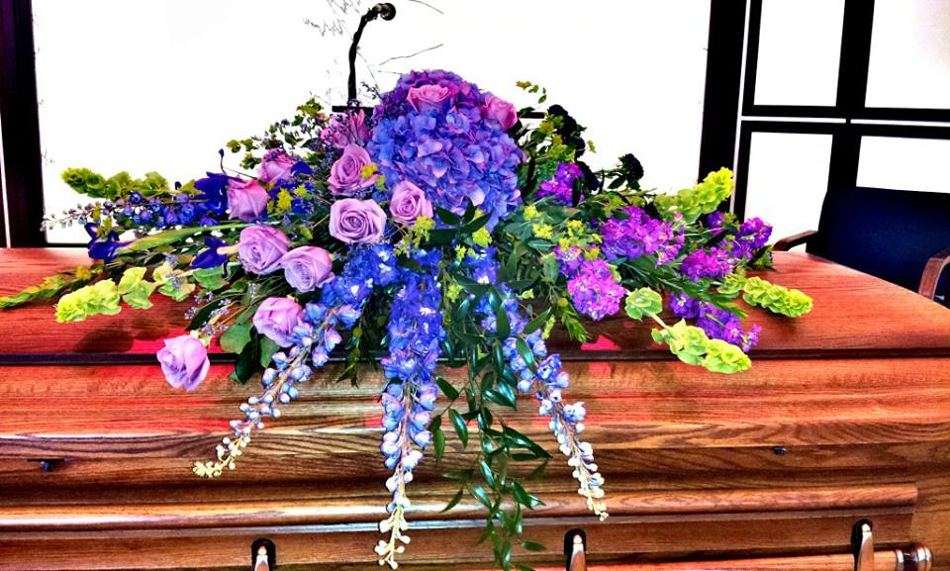

Final Resting Place

Some things to consider when choosing a final resting place are the decedent’s religion, military service, family plots, or culture. Cemeteries are responsible for preparing the burial site, placing the decedent in their final resting place, installing the memorial marker and the care and maintenance of the area. Most cemeteries offer several choices for the final resting place. A mausoleum, which is an above ground building designed to house both a full casket and cremated remains. An outdoor columbarium or urn garden is a wall structure usually made of granite or marble with several niches. An urn garden holds the cremated remains in an outdoor location. If a family has chosen to donate the remains, or keep or scatter the cremated remains of their loved one, a columbarium can offer a memorial plaque on the space to commemorate the deceased. A lawn/ground burial is where a burial space is chosen and the decedent or the cremated remains are placed in the ground. Many cemeteries have rules for the types of memorial marker that can be placed on the graves, so be sure to ask.
Choosing a Cemetery
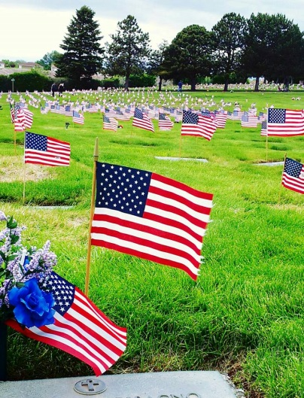
There are four main types of cemeteries that you will want to consider. The first is a public cemetery; this is the most common type of cemetery and is generally for-profit. These can be independently or corporate owned. However, some may be run by a local organization and can be non-profit. It is best to ask if this is a concern. The next is a religious cemetery. These are generally non-profit and are owned by a religious organization. It is advised to consult with your local church, synagogue or mosque to locate the cemeteries in your area and for further information. The third type of cemetery is a district or municipal cemetery. These are non-profit and are usually owned by the city or county. Depending on the size of the city or municipality, these may be full or only allow residents who are destitute. The last type of cemetery is a national or veteran cemetery. These are run by the government and are generally used for the burial of veterans and their immediate families. They usually include basic burial arrangements and military honors. If this type of cemetery is not available in your area or you choose a different cemetery, you may still be able to include the military honors as part of your service.
When choosing a cemetery, it is best to visit and assess how the grounds are maintained. This includes the cleanliness of the mausoleum and that the landscaping is being upheld. Speak with the staff and ask questions. Your loved one is going to stay at this location and you will want to verify that it is continually maintained.
There may even be a possibility that your chosen location is in another city or state. A full service funeral home should be able to make arrangements with you to transfer the decedent or cremated remains safely and in accordance with all laws. This is important to consider if your loved one has passed away in another state and you need them transferred to Nevada. Each state has different laws about the process and who can transport any remains. Be sure to contact a funeral home in both states to ensure that all laws are being followed.

Donation of Remains

An alternative to consider is to donate all or part of the remains. Donation does not affect the ability to have a memorial service or viewing. Depending on your family’s situation, you may elect to donate organs and tissues for transplants that can help save hundreds of other lives. Another option is anatomical donation to medical science where the deceased is given to medical schools in order to teach anatomy and to study disease. If you choose anatomical, keep in mind that none of the organs may be used for transplants.
With donating tissue and organs for transplants, almost everyone can donate something, regardless of their age or medical condition. Just one organ donor could possibly save up to eight lives. Just one tissue donor can help over 50 patients, especially those who are burn victims. Currently, there are over 100,000 people on the national transplant list, and on an average day 16 people die awaiting a transplant.
If you choose to be a donor, the best way is to join the Nevada State Organ & Tissue Donor Registry. You can do this by going to the DMV and have them enter your name in the registry or you can go directly to the registry and enter yourself. Once you have made the decision to be a donor, be sure to inform your family. Knowing your wishes ahead of time, takes the burden of that decision off of your family.
For more information on organ and tissue transplant:

Nevada Donor Network  1875 Plumas, Ste #6  Reno, NV 89509  2061 E. Sahara Ave  Las Vegas, NV 89104  Toll Free 855-NVDONOR (683-6667)  NVDonor.org | Sierra Donor Services  1760 Creekside Oaks Drive, #220  Sacramento, CA 95833  Toll Free 877-401-2546  SierraDonor.org | The Transplant Network  University of Nevada School of Medicine  (775) 784-6171  TheTransplantNetwork.com

Having a Viewing or Funeral Service

A funeral service can be traditional, non-traditional, religious, or a military service. No funeral is the same and it may even be a combination of these types. Again, no person is the same, nor should their service. It should be tailored to the family’s individual desires. A full service funeral home can help guide you through the entire process including a viewing or memorial service, if you choose to have one. Most funeral homes offer a small viewing room for the immediate family. Some may have larger facilities available for larger gatherings or receptions for the family.
Before choosing the type of viewing or funeral service, understand that certain circumstances require an embalming. Those circumstances include a funeral with a public viewing and/or visitation, the decedent is being transported out of state or if the death is from a communicable disease. Otherwise is it the family’s decision to have an embalming for the funeral.
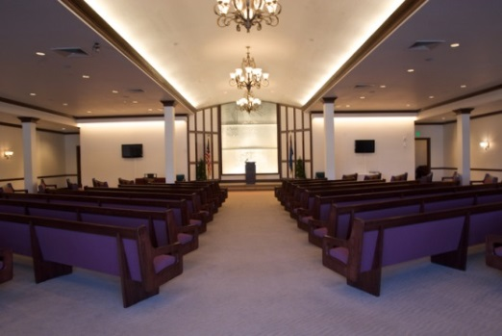
When preparing for a viewing or funeral service, a full service funeral home can assist with many of the details including contacting the appropriate clergy and coordinating the site for the service, including the decedent’s church, the grave site, or an onsite chapel. Some funeral homes may even have a space appropriate for a reception following the service, including catering. If the decedent was prior military, you may want full military honors at the service. Most funeral homes can coordinate with Veterans Affairs and help with appropriate paperwork to have this available.
Some other items to consider with a funeral service is to have a memorial book or board, memory video or slideshow, music, religious articles, and flowers for the memorial, including flowers for the pallbearers and immediate family/friends.
A full service funeral home also provides transportation of the decedent and immediate family/friends, including a funeral coach, to and from the funeral home to the funeral service and the final resting place. This generally includes the transportation and set up of flowers and memorial or religious items at the each location.
A full service funeral home can assist with many of these arrangements and more including writing and publishing the obituary, obtaining the death certificate and contacting social security.

After the Funeral

In the weeks and months following a death of a loved one, you or other family may have trouble returning to normality. After the commotion of a funeral, it is sometimes difficult to return to daily life when your loved one is no longer there. Some funeral homes now offer grief counseling to mourners or may be able to refer you to someone in the community. Also, there are many good books and articles that can help. Whether you visit a counselor or not, you still need to allow yourself to mourn. It is okay to feel emptiness or loss after the funeral is over. You may also feel a complete numbness or a multitude of emotions. Each person handles life differently and will grieve differently. Even if two people were equally close to the decedent, neither one will handle it the same. These feelings are normal and only you can decide when these feelings have waned.
Some practices to consider are to develop a support system, talk openly about your grief. Embrace your spirituality, and allow yourself to search for a meaning. You may not find all of the answers you are looking for, but it may help with moving forward. Treasure your memories, memories are the best legacy left by a lost loved one. Some may make you laugh and others may make you cry, but all of them are yours.
The most important final step in the process is to start living. Slowly, get back to daily activities. Take a day-at-a-time approach. It may be tiresome, both physically and mentally, but as you get through each day, the grief becomes easier to manage.

Important Points to Consider

There will be some paperwork to fill out, regardless of where you arrange the funeral. A full service funeral home will assist with much, if not all, of this paperwork. There is a considerable amount to remember and a respectable funeral home will assist you with the necessary paperwork and information. This can be a stressful time and it is easy to forget significant information. There are also many government and religious organizations to contact, including clergy, Social Security and Veterans Affairs to name a few. You need to be able to trust your funeral director to assist and provide you with all of the necessary documents and forms. A good funeral director will aid in the process by ensuring that you are aware of all necessary and many desired procedures.
The Federal Trade Commission requires that funeral homes offer their prices in writing in the form of a general price list and casket price list. While price is not the only consideration when planning a funeral, it is important to evaluate the price along with the amenities that are offered by the funeral home.
A funeral director should be a guide. While all necessary services are provided by the funeral home, a reputable funeral home will assist you if an outside resource is preferred.

Closing Remarks

When comparing final arrangements, it is important to make sure you have a complete picture. Not all funeral homes offer the same services. Each family is different and has different needs. A good funeral home will guide you through the process from the initial passing to the grief afterwards. When choosing a funeral home, it is important to ask questions and visit with funeral directors. This is a sensitive time in your life and you need to be comfortable with a funeral home that will treat you and your loved one with dignity and care.
It is our hope, at Mountain View Mortuary, that you have found this guide to be helpful whether you need to immediately start funeral arrangements or are looking for future information. We invite you to contact us if you have further questions or concerns.
Call (775) 788-2199 and ask to speak to our funeral director. Any of our staff will also welcome the opportunity to share more with you about our services. You are also welcome to visit our website at MountainViewMortuary.net where we have additional information.
